**21 CARDS TRICK**

**BACKGROUND**

The 21 Cards Trick is an interactive card trick using 21 cards randomly picked from a full deck of playing cards. The user picks and memorizes a single card. The computer asks the user a few questions and then guesses the user’s chosen card. This is a card trick based on a mathematical algorithm. The computer will always present the correct card.

**INSTRUCTIONS**

Only 21 cards are needed for this trick, which are taken from a full deck of shuffled playing cards.

1. The user picks a single card that the computer is to guess.
2. The computer divides the 21 cards into three columns of seven cards.
3. The computer asks the user which of the three columns their card is in.

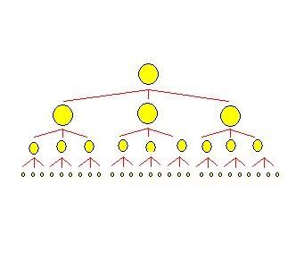

1. Step 3 is repeated two more times.
2. The computer guesses the user’s card.

**SEARCH STRUCTURE**

The data structure for this card trick utilizes a 3 x 3 decision tree (each node has three children).

The data structure has nine possible pathways with a total of 27 possible outcomes. Using this model, the target node can be identified in three decision steps.

Possible Outcomes = 33 = 27 Pathways = 32 = 9 Decision Steps = 31 = 3

**ALOGRITHM**

The first time the user tells the computer the column (i.e., list) their card is in, the computer appends the columns into one list with the target column being at the center. Next, the list of 21 cards (i.e., elements) is again split into three columns of seven, with the target column in the middle. This function repeats two more times for a total of three iterations.

The data structure for this card trick is linear system with a 3 x 7 matrix. By transposing the matrix three times and always including the target column in the center, the target card (i.e., target element) will always be the 11th position in in the 21-element array.

